CSC 340 Ethics and Software Engineering

John Booker

Individual Calendar

User Manual

Contents

I. Introduction 2

II. Operations 2

See Monthly Events 2

View an Event 3

Add Event 4

Delete Event 6

The system shall allow a user to edit a created event. 8

# Introduction

This is a user manual for John Booker’s Individual Calendar System.

# Operations

## See Monthly Events

1. Go to the month you would like to see the evens for
2. Make sure the date selected is within that month
3. 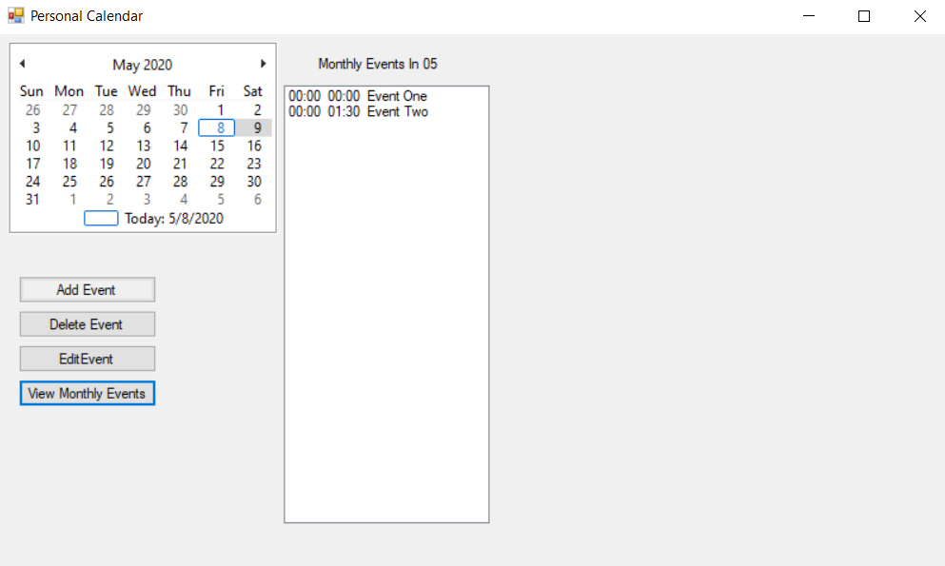Finally, click the “View Monthly Events” button at the bottom left.

## View an Event

1. Go to the month of the event you would like to see
2. Select the day of the event
3. Click on the event you want to see details of; listed inside the long events box in the middle of the screen
4. The details of the event will now appear on the right collumn

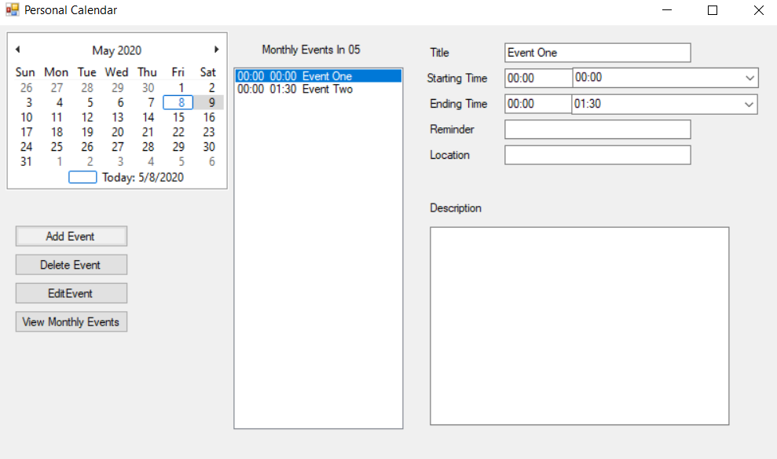

## Add Event

1. Navigate to the month you would like to add the event to
2. Select the day from the calendar that you want the event to be on
3. 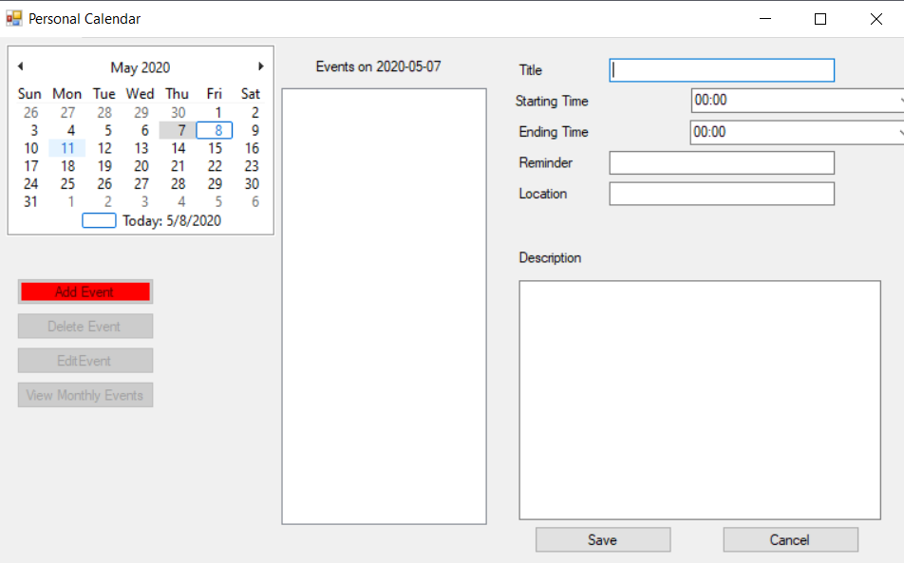Click the “Add Event” button on the left side
4. Fill in the event’s information on the right side
   1. Event times must be in increments of 30, use the dropdown boxes to select them.
5. Now press the save button, to save; or cancel to abort making an event.
6. If save is pressed; the program will save your event, unless it conflict with another time or some other factor. A popup will appear to let you know if it has saved successfully or if there was an issue.
   1. 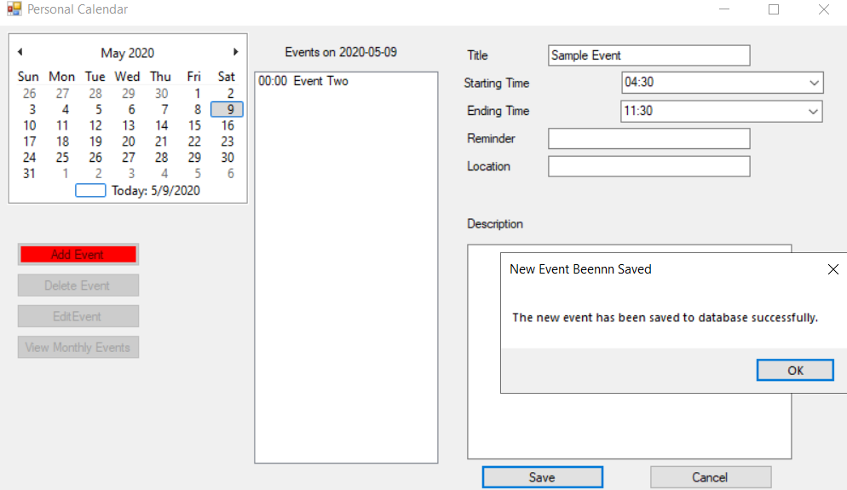Success:
   2. 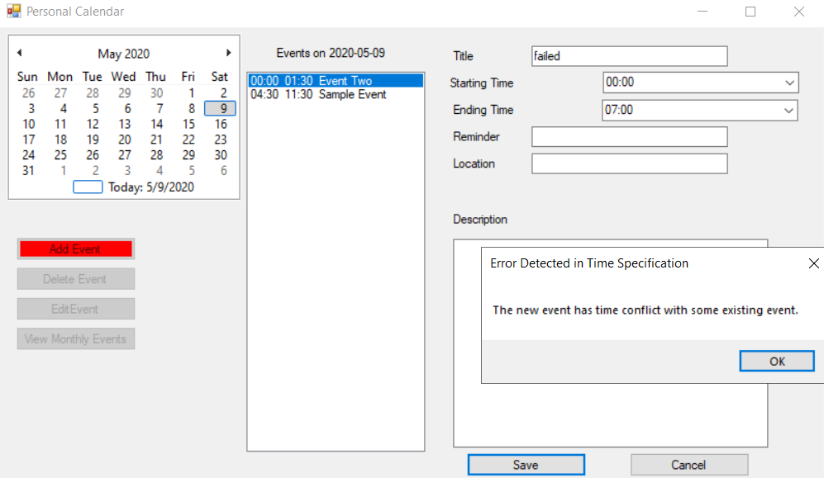Failure:

## Delete Event

1. Go to the day and month of the event and select it, just like you would to view it.
2. Press the delete button on the left side

## Edit Event

1. Go to the event you want to edit, like you do to view it
2. Make any changes to the details you would like.
   1. For times, you must change the times inside the dropdown boxes
      1. The boxes next to the dropdown boxes show the current time of the event, not what you are changing it to.

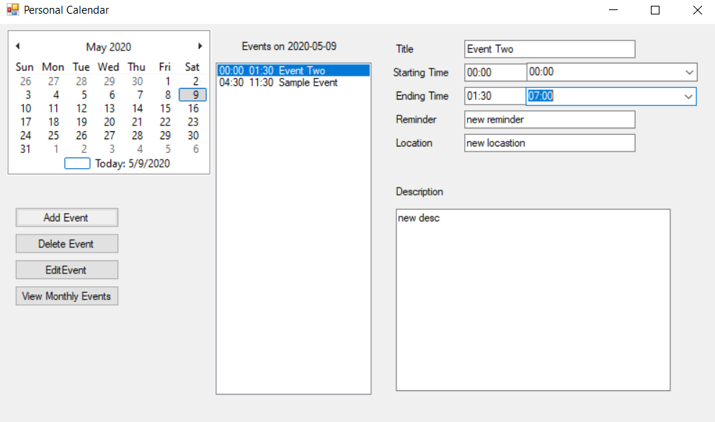

1. After your changes are done, click the “Edit Event” at the left of the screen
   1. Just like with adding an event, there will be a popup noting success or failure of the edits.